6.65: 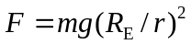
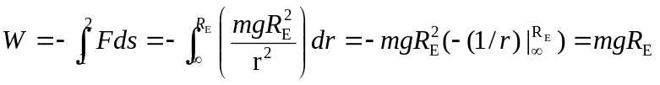
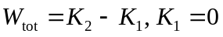
This gives 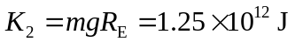
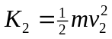 so 